TAPS Plan for Focused Assessment of Science

Topic: Materials | Year 2  Age 6-7 |  | Title: Materials hunt
Working Scientifically  Do: gather and record data to help in answering questions |  | Concept Context  Identify and compare the suitability of a variety of everyday materials
Assessment Focus
- Can children observe closely to find objects made of different materials?
- Can children record their findings?
Activity Today we are materials scientists.
In Year 1 children would have spent some time distinguishing between an object and the material from which it is made. Recap this with the children by identifying and naming a variety of everyday materials in the classroom, e.g. wood, plastic, glass, metal, and rock.
Consider how to classify objects which are made from more than one material e.g. record most important part, or make a ‘mixed materials’ row on recording table.
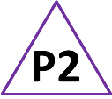
Ask groups of children to go on a materials hunt around a designated section of the school/grounds, collecting their findings for different areas on a pre-prepared table and/or using a camera.
Collate class results, noting with the children different ways to record data clearly.
Discuss the uses of different materials around school and consider why different materials are used for different purposes.

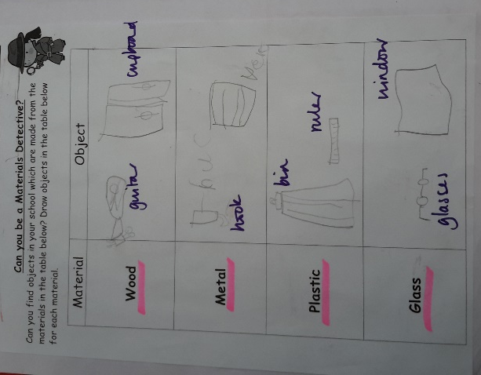
Adapting the activity
Support: Scribe names of drawn objects.
Extension: Record useful properties of materials.
Other ideas: Investigate other areas e.g. home, outdoors.

Questions to support discussion
- What can you see which is made from x?
- What is this made from?
- Did you find anything made from x?
- What did you record in this part of the table?
- Which material did you find the most/least of?
- Did you find anything which used more than one material? How did you record that?
Assessment Indicators
Not yet met: Describes some materials or objects, but finds it difficult to categorise into types of materials or explain what they recorded.

Meeting: Records their observations of a range of objects made from different materials. In discussion, makes links between properties of materials and their uses.

Possible ways of going further: Notes findings which are similar or different to their own. Continues to ‘hunt’ materials at other times and/or in other locations.

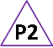 Pupil box 2 - focus on science objectives. See TAPS pyramid for more examples.

