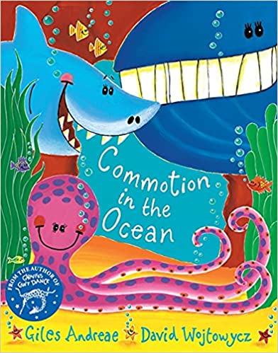

**Perran Class:**

**How can we fix the commotion in the ocean?**

**Outcome:**

Complete a beach clean followed by a presentation to parents/school explaining what we have found out during our project.

Music

Charanga!

Hands, feet, heart

Ho, ho, ho

Recognising pulse, rhythm, style of music,

Making music

Useful links:

Maths Shed and Spelling Shed

[www.edshed.com](http://www.edshed.com)

TT Rock Stars <https://ttrockstars.com/>

TRIPS/EXPERIENCES:

Visit the beach for hands-on science;

Work with Plymouth aquarium on their sea-grass project <https://saveourseabed.co.uk/>

Harvest Festival / Remembrance Day / Christmas nativity;

Beach clean and presentation of our findings

PE

Gymnastics, rolling, jumping, twisting, balancing;

Showing an awareness of space;

Outdoor play using equipment and obstacles;

Throwing and catching;

Ball skills;

Fine & gross motor skills

RE

The Creation, who made the world?

Harvest Festival;

What does it mean to belong to a faith community?

Christmas nativity

**Our Curriculum makes the most of our 3 ‘E’s:**

Excellence, Equity and Evolution. They can be found throughout our planning and are reinforced continuously with the children.

Art & DT

Transient art;

Seascapes;

Dot Day: look at Kandinsky’s work;

Collage;

Observational drawing;

Design and construct a litter collector;

Firework art

Remembrance Day poppies;

History & Geography

Comparison with Victorians including photographs,

The beach then and now;

To know the 7 continents;

To recognise the names of the 5 oceans

Using google maps and google earth

Looking at the human and physical features of a coastal town

Be aware of their locality/environment

**Hook:**

Ask children to sort a collection of flotsam and jetsam from the beach!

Discuss what they have done.

What you can do to support your child’s learning:

Visit the library together and look out for books that link to our project;

Read with your children (you to them and them to you);

Encourage your child to write sentences using neat handwriting, capital letters, finger spaces and full stops;

Count in ones to 20 and beyond (Yr1)

Count together in 10’s to 100 and back to 0, in 2’s to 20 & 5’s to 50. (Yr2)

Discuss 1 more, 1 less and extend to 10 more and 10 less

Support your child with homework tasks

PSHE

Being me in my world;

Celebrating difference.

English

Stories with fantasy settings,

eg: Rainbow fish, Duffy’s lucky escape, Marli’s tangled tale, Commotion in the Ocean;

Recount writing& dictionaries;

Poems & alliteration;

Information texts~ non-fiction writing;

Writing signs, labels & captions;

phonics;

handwriting practice;

Sentence structure;

Mathematics

Number/calculation: counting to 100;

Place value within 10/20 and beyond;

Read and write numerals to 20 (and beyond) and order them;

1 more, 1 less / 10 more, 10 less;

Addition and subtraction within 10 (and beyond);

Geometry, name 2D and 3D shapes;

Maths shed

Science

Beach fieldwork looking at:

Habitats;

Rockpools;

Life-cycles of animals;

Identify and name a variety of common animals;

Observe changes in Autumn, especially to trees

Computing

Ongoing skill development including:

IT around us

Creating media

Programming

Pictograms