**MATHEMATICS**

* Perimeter and area
* Compare and order fractions.
* Recognise mixed numbers and improper fractions.
* Adding and subtracting fractions.
* Multiply mixed numbers and proper fractions.
* Read and write decimal numbers as fractions.
* Read, write and order decimals numbers up to 3 decimals places.
* Round to 2 decimal places.
* Recognise and understand percentages as a number of parts per hundred.
* Solve problems using fractional, decimal and percentage knowledge.

**ENGLISH**

* Read a Sci-Fi adventure and use this to inspire their own fictional story.
* Appeal to intellect through reasoning and evidence – Did we land on the moon?
* Narrative poetry
* Newspaper Article and script writing
* Non-Chronological report based on London
* Develop knowledge of spelling patterns, grammar and cursive handwriting.

Class Reads

* Cosmic Collin in the Stinky Space Race (Tim Collins)
* Cosmin (Frank Cottrell-Boyce)
* First Newspapers

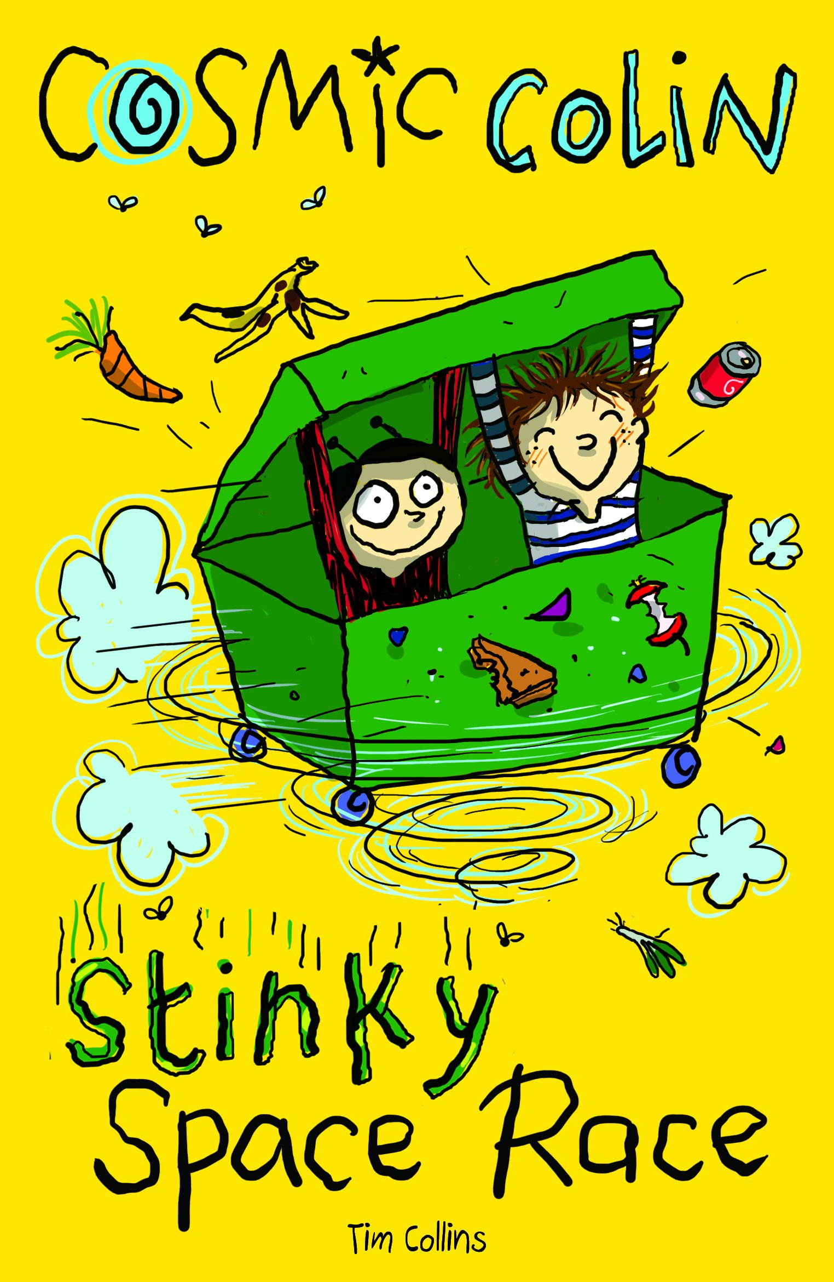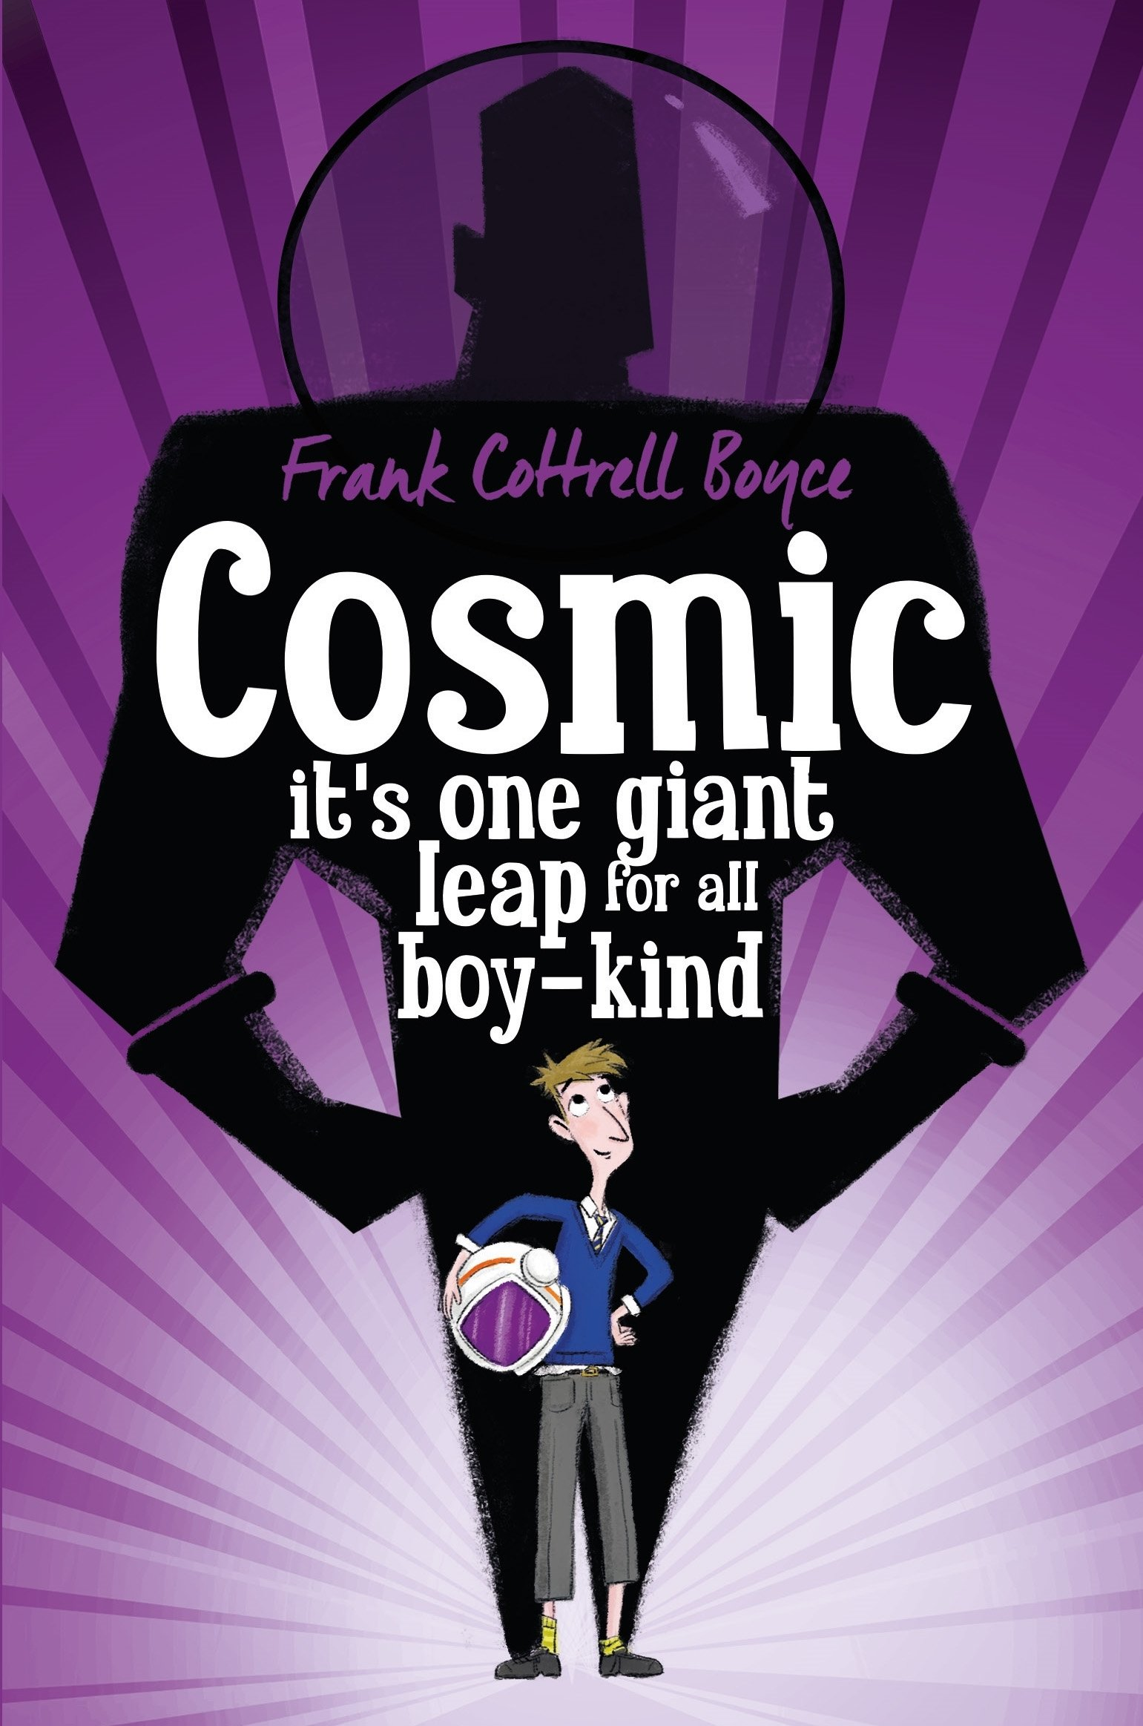

**SCIENCE**

**Earth and Space**

* Describe the movement of the Earth and other planets relative to the sun in the solar system.
* Describe the movement of the moon relative to the Earth, the sun, Earth and moon as approximately spherical bodies.
* Use the idea of the Earth’s rotation to explain day and night and the apparent movement of the sun across the sky.

**Forces**

* Explain the force of gravity acting between the Earth and a falling object.
* Identify the effects of air resistance, water resistance and friction that act between moving surfaces.
* Recognise that some mechanisms including levers, pulleys and gears allow a smaller force to have a greater effect.

**GWENVER CLASS**

**ICT**

(Ongoing skill development, plus ...)

* Recording Podcasts
* Programming and coding with Scratch

**TO INFINITY AND BEYOND**

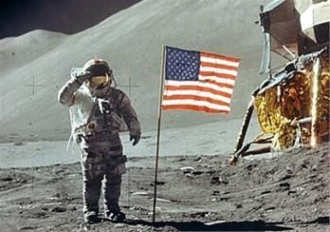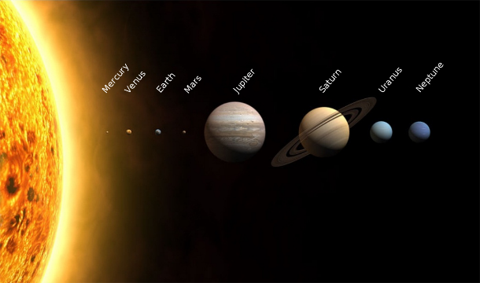

**HISTORY/GEOGRAPHY**

* Positional significance (hemispheres, latitude, longitude etc.)
* Use the 8 points of a compass, 4 and 6-figure grid references, symbols and key
* Understand geographical similarities and differences through the study of human and physical geography of a region of the United Kingdom- London

**ART/DESIGN/MUSIC**

* Oil pastel space scenes inspired by Chesley Bonestell.
* Exploring form, line, tone, colour and shape inspired by Peter Thorpe
* Creating space inspired sound using manipulation and experimentation.

**TRIPS/EXPERIENCES**

**Bikeability**

**Volunteer in the community / Charity work**

**Dance workshop at the Minack theatre**

**Year 5 Podcasting**

**London Trip**

**PE**

* Dance
* Football / Rugby
* Daily Mile

**RE**

* Sikhism and Buddhism
* Morals and ethics

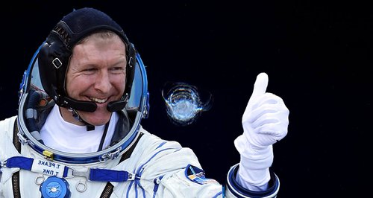

**PSHE**

* Discussing both national and global affairs and their impact.
* Implementing e-safety strategies.
* How to develop and maintain a variety of healthy relationships, within a range of social/cultural contexts.

**Essential Question:**

**How can we shine as brightly as the stars?**

**REAL outcome:**

**Film / Podcast 🡪 To showcase how we have shined as brightly as the stars**