**MATHEMATICS**

* Identify equivalent fractions & decimals, simplify fractions.
* Recognised fractions of quantities.
* Understand decimal notation (tenths, hundredths).
* Multiply & Divide numbers by 10, 100, 1000.
* Understand Area & Perimeter.
* Estimate and measure using units of length & weight e.g. mm, cm, m, g, kg – convert measurements.
* Develop the telling of time including roman numerals.
* Plot co-ordinates of shapes.

**Class 4 – Gwithian**

**Where and how do natural disasters happen?**

**ENGLISH**

* Exploring the form of poetry such as Haiku, Tanka & Cinquain.
* Short stories linked to the topic
* Play scripts – to entertain.
* Explanation texts – to explain how or why something works / happens.
* Develop and secure knowledge of spelling patterns.
* Write dictation sentences.
* Improve cursive handwriting.
* Develop inference and deduction skills in reading comprehension.

**TRIP - Visit to shelter box**

**OUTCOME – a mini play linked to the story ‘Escaping the Great Wave.’**

**Residential to Delaware.**

**ART/DESIGN/MUSIC**

Create paintings and prints linked to Magritte’s ‘Eye of the Volcano’ & Hokusai’s ‘The Great Wave’

Pastel drawing of a volcano.

Make pop up cards of the Great Wave

Sing ‘Volcano’ and ‘Water Cycle’ songs.

Compose music about natural disasters and the water cycle.

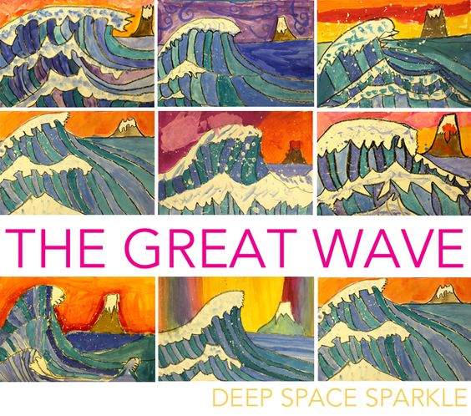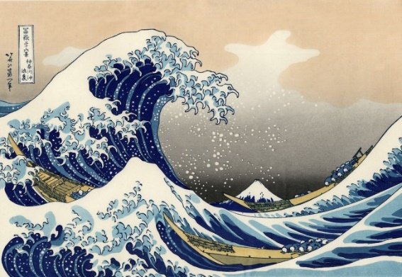

**SCIENCE**

Investigative science

Carry out investigations, predict outcomes and evaluate these effectively.

Make careful observations and use scientific vocabulary accurately.

Changing of state

Describe differences between the properties of solids, liquids and gases.

Understand reversible and irreversible changes.

The Water Cycle

Use scientific terms e.g.: evaporation, condensation to describe changes.

Understand the stages of the water cycle

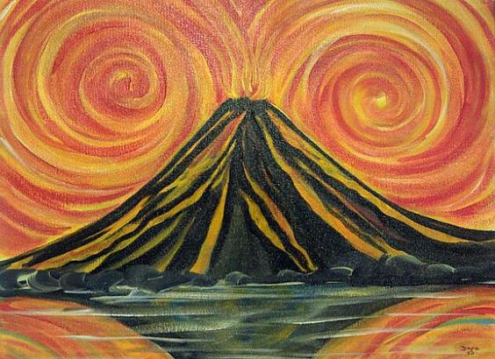

**PE**

* Swimming (6 weeks +4 if needed)
* Invasion games including rugby & football.
* Gymnastics

**COMPUTING** Use computer-based data logging to record some weather data. Producing a wiki linked to our topic.

**PHSE**

**DREAMS AND GOALS**

Recognise worth as individuals, setting personal goals.

Be responsible for their actions and care about the feelings of others.

**HEALTHY ME**

Knowing the importance of being healthy in all aspects of life.

**RELIGIOUS EDUCATION**

Recognise various Jewish artefacts including the holy book.

Understand Jewish festivals and the traditions within these.

Understand early Christianity.

**GEOGRAPHY**

Recognise different natural disasters and their impact on the environment including; Volcanoes, Earthquakes, Tsunamis, Hurricanes & Floods.

Identify the world’s main volcanoes and understand the effect it has on human life and animals.

Understand how Earthquakes occur and the scale used to record them.

Develop secure understanding of where countries are around the world using atlases/ maps