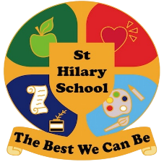
Religious Education (RE) Intent At St Hilary
It is our intent that Religious Education helps pupils to find out what people believe and what difference it makes to how they live. RE helps pupils to make sense of different religions and beliefs, reflecting on their own ideas and ways of living.
It promotes respect and open-mindedness towards others with different faiths and beliefs and encourages pupils to develop their sense of identity and belonging through self-awareness and reflection.
It will promote the spiritual, moral, cultural, mental and physical development of pupils and prepare pupils at the school for the opportunities, responsibilities and experiences of later life.

Implementation of Religious Education At St Hilary

At St Hilary School we follow the Cornwall Agreed Syllabus for RE 2020-2025. For some year groups, this also incorporates a Cornish aspect, which enables pupils to explore the rich spiritual and religious heritage of Cornwall and the relevance of this for people in Cornwall. 50% of the RE Cornwall Agreed Syllabus covers Christianity for which we use the national resource ‘Understanding Christianity’.

Legal requirements for Religious Education:

Religious Education is a statutory subject of the curriculum for all pupils in each year group and should be provided for all registered pupils except those withdrawn at the request of their parents.

Parents have the right to request that their son or daughter be excused from all or part of the RE provided at school.
The syllabus should ‘reflect the fact that the religious traditions in Great Britain are in the main Christian, while taking account of the teaching and practices of the other principal religions represented in Great Britain.’ (s375 (3) Education Act 1996)
Religious Education is generally taught on a weekly basis, but is sometimes delivered through a class topic or as a whole-school RE day/ half day. Teachers may develop their own key questions linked to the themes in the syllabus, allowing links with other subject areas where appropriate.

Lessons are planned and delivered in a variety of ways ensuring that all children can access and participate in lessons. Interactive, practical activities encourage the children to discuss their ideas and extend their understanding of difficult concepts and challenging questions.

Implementation Through the Cornwall Agreed Syllabus

One religion is studied at a time (‘systematic’ units), and then ‘thematic’ units are included, which build on learning by comparing the religions, beliefs and practices studied.
It means that pupils encounter core concepts in religions and beliefs in a coherent way, developing their understanding and their ability to handle questions of religion and belief.

The teaching and learning approach has three core elements, which are woven together to provide breadth and balance within teaching and learning about religions and beliefs.

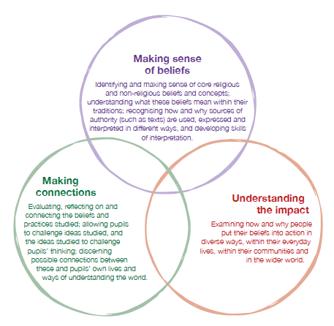

Teaching and learning in the classroom will encompass all three elements, allowing for overlap between elements as suits the religion, concept and question being explored.

These elements set the context for open exploration of religion and belief.

They offer a structure through which pupils can encounter diverse religious traditions alongside non-religious worldviews – which reflects the different backgrounds pupils may have.

The elements present a broad and flexible strategy that allows for different traditions to be treated with integrity.

These elements offer a route through each unit while also allowing for a range of questions reflecting different approaches, for example, from religious studies, philosophy, sociology, ethics and theology.

Pupils’ progress in RE is assessed termly by each class teacher.

Concepts in Religious Education

The Cornwall Agreed Syllabus and Understanding Christianity use a ‘spiral’ curriculum, where pupils revisit core concepts in different contexts as they move through the school. These varied encounters deepen pupils’ understanding of the meaning of these concepts as they progress through their learning about different religions.

The key subject concepts as decided across the Leading Edge MAT are:

Key Stages | Subject Concepts – Religious Education
Key Stage 2 | Identity Traditions Narratives Culture Perspectives Beliefs Global interactions
Key Stage 1 | Identity Traditions Narratives Culture Perspectives
EYFS | Identity Traditions Narratives

Understanding Christianity units then follow the concepts below, which help deepen pupils’ understanding of the meaning of these within the overall ‘big story’ of the Bible.

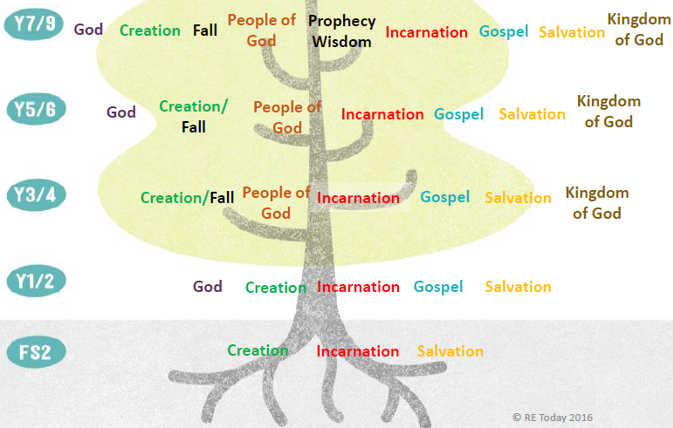

Impact of Religious Education (RE) At St Hilary

Through the Cornwall Agreed Syllabus it means we are responding to national calls for deepening pupils’ knowledge about religions and for developing their ‘religious literacy’.

The impact of using these concepts within a ‘spiral’ curriculum in this way means that:

- It weaves in opportunities for pupils to reflect upon these ideas in relation to their understanding of religion and belief,

- Increases pupils ‘religious literacy’ so pupils’ can understand the nature and impact of religions and beliefs in the contemporary world, and so they can articulate informed responses about religion and belief.

- Enables pupils to grasp the meaning and significance of core theological concepts within Christian and other religions beliefs and practices. This understanding means they can begin to reflect upon and evaluate different ways of understanding the world, including their own ideas.

- Enables pupils to begin to develop the skills of ‘theological enquiry’ and engage in investigating significant questions about God, faith, authority and how to live. They are encouraged to ask appropriate questions of their own.

Through teaching of Religious Education we hope to develop happy, motivated and confident children who show consideration, respect and understanding for others.

