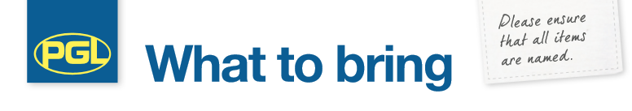
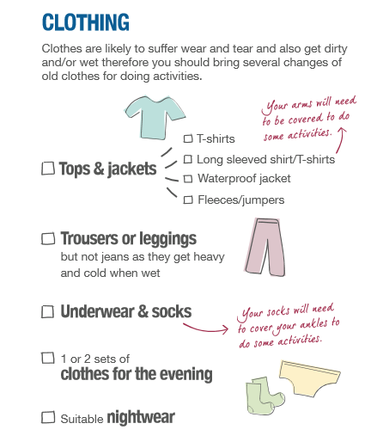
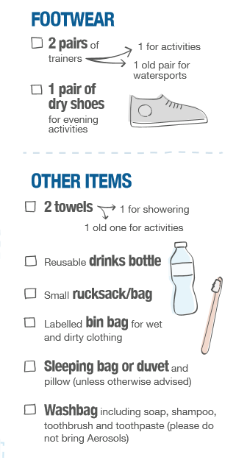

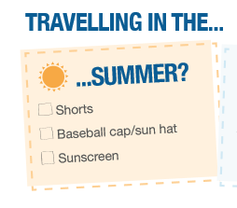

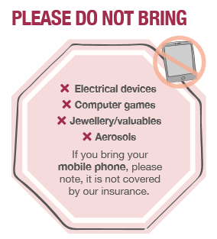
Pocket Money:
There is a shop on-site selling souvenirs and sweets – please ensure that your child does not bring any more than £10 in a wallet or purse – your child will have full responsibility for this.
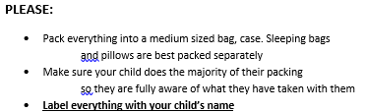
X mobile phones
