GEOGRAPHY at St Hilary School
Key knowledge & skills
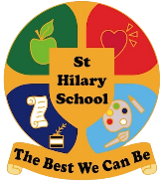
Develop a knowledge of the local area, the UK and other countries. Know the human and physical features and aspects of geography.
Develop and use geographical skills and fieldwork.
By the end of Y6, children will have learnt about and be able to discuss:
- a sense of place and scale, where we are in the world
- our local environment, cities and countries of the UK, continents and oceans of the world and contrasting countries
- How environments change, similarities and differences, climates and sustainability
- Interconnections of human and physical aspects and their impact
Key Principles
- Locational Knowledge - Place Knowledge
- Human & Physical geography - Geographical skills and fieldwork
Subject Concepts
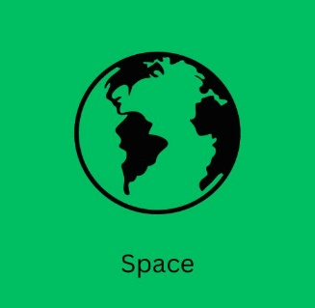
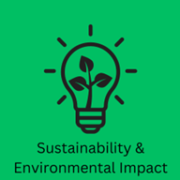
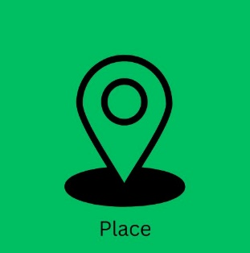
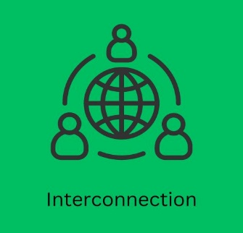
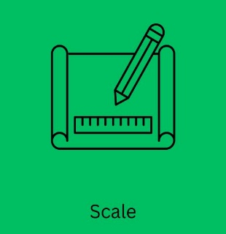
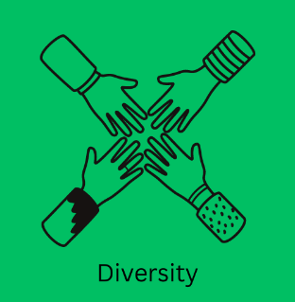

Vocabulary Tier 2/3
EYFS | Y1 | Y2 | Y3 | Y4 | Y5 | Y6
home  school  road  farm  beach  cliff  woods | rural  urban  local  country  continent  ocean  map  town  village  city  weather  seasons | human features  physical features  symbols  population  Equator  coast | land use  industry  tourism  development  tourism  culture  hemisphere  rivers  water cycle | economy  trade  sustainable development  scale  distribution  settlement | biomes  biodiversity  climate  time zones  contours  renewable energy | landscape  latitude  Tropic of Cancer  Tropic of Capricorn  axis  longitude  grid reference  data collection

 | Place  A sense of place that carries meaning.  Distinctive features, landscapes and community | Space  Spatial understanding of location, distribution and distance | Sustainability &  Environmental  Impact  The idea that humans interact with the environment to protect and ensure resources for the future | Interconnection  How physical and human features and processes are linked and impact each other | Scale  The relationship between distance on the map and distance in real life. | Diversity  Cultural awareness  Understanding similarities and differences between people, cultures, environments and places
EYFS | ELG Understanding the world  People, Culture and Communities  Describe their immediate environment using knowledge from observation, discussion, stories, non-fiction texts and maps.  Explain some similarities and differences between life in this country and life in other countries, drawing on knowledge from stories, non- fiction texts and (when appropriate) maps.  The Natural World  Know some similarities and differences between the natural world around them and contrasting environments, drawing on their experiences and what has been read in class.  Understands some important processes and changes in the natural world including the seasons.  Projects: Me, Myself and I ! Where does my breakfast come from? What’s In My Bag?  My home, school & local environment Food and Farming in Cornwall The jobs people do in our local community  Welly walks around the local environment Trips to local farms: Trink Dairy & Cornhill Visits from Police/Fire/RNLI Parents & careers
Year 1 | I can say where me and my family come from and share my favourite place  I can talk about the similarities and differences between town and countryside | I can talk about some key features of our locality  I can point out and talk about the 4 countries of the UK and their capital cities I can point out the United Kingdom on a world map or globe | I can talk about what the land around school is used for  I can use simple observational skills to study the geography of our school  I can talk about Earth Day and looking after our planet.  Enquiry Question:  How can we fix the commotion in the ocean?  Plastic pollution on Marazion beach. The Torrey Canyon shipwreck disaster. Local beach clean | I can point out similarities and differences in my own area.  I can use basic geographical vocabulary such as town/village/beach/sea | I can make a map of my school and local area and look at aerial photos | I can tell you about changes in the weather in our country and in a contrasting location.  How do people in hot/cold climates adapt to their environment.
Year 2 | I can point out similarities and differences of my own area and of another area in the United Kingdom  I can talk about/point out similarities and differences between my own area and a small area of a contrasting non-European country  Enquiry Question:  Where in the world are we and where can we go?  Comparing Cornwall’s physical & human features to the locality of Tromso in Norway | I can name the 7 continents and 5 oceans | I can say why some areas of the world are hotter/colder  (eg near the equator, close to the North or South Poles)  I can carry out fieldwork skills of our surrounding environment  I can tell you how we can look after our planet by reducing, reusing and recycling. | I can use basic geographical vocabulary to describe and compare human and physical features | I can draw symbols on maps  I can use compass directions  I can use words to describes routes and locations on a map | I understand that people/children come from other countries with different religions beliefs and cultural identity
Year 3 | I can talk about how the UK is divided up into regions called counties and that Cornwall is our home county  I can describe what is similar and different between a place in the UK and South America ( Brazil) | I can compare an area in my locality (Chysauster) with another UK locality ( Skara Brae)  Enquiry Question:  Through the ages, where will our journey take us?  Fieldwork trip to Godolphin Hill, rocks and soils  Chysauster, Carn Euny iron age forts | I can describe aspects of physical geography such as rivers and the water cycle.  I can measure and record the physical features of a local river I can explain how we can look after our planet by reducing, reusing and recycling.  Enquiry Question:  Can a river be a gift?  Why the River Nile played such an important part in the lives of Ancient Egyptians. Food/trade/travel  Local river survey. St Erth River & Red River Marazion | I can distinguish between physical and human features and use geographical vocabulary to describe an area  I can talk about biomes and vegetation belts | I can study maps, keys and symbols to find rivers  I can locate countries of Europe on a map | I can tell you some similarities and differences between life in the UK and life in South America.  What is it like to live in Brazil? Traditions, customs and way of life.
Year 4 | I can describe what is similar and different between a place in the UK (The Scillies) and a region in Europe ( Sicily)  Enquiry Question:  Would it be Scilly to chose Sicily?  Comparing human and physical features of both Islands | I can locate The Isles of Scilly and Sicily in Italy on a world map and know the distance between them | I can understand key aspects of climate zones, volcanoes and earthquakes  I can explain the environmental impact of earthquakes and volcanoes  I can explain the consequences of climate change and the need to be green. | I can describe types of settlement and land use  I can explain the consequences and changes to a locality after volcanic activity or earthquakes  Natural Disasters play | I can use the 8 points on a compass and simple grid references.  I can explain how earthquakes are measured using the Richter scale | I can explain how Italy is different from The Scillies and what is it like to live in these two contrasting localities.
Year 5 | I can explain the similarities and differences between our locality and London, the capital city | I can locate some counties in England and understand the distance from Cornwall to London during our residential trip to the capital  Enquiry Question:  Are we really miles apart?  The space race. International and local impact. Newquay space port | I can observe, record and present the physical features of a city on our trip to London. A settlement along the river Thames  I can discuss the benefits of renewable energy and explain the causes of climate change.  I can explain changes to our climate and the impact of global warming | I can understand types of settlements and economic activity including trade links.  The impact of Vikings and Anglo Saxans on Great Britain and compare to The Maya. | I can use atlases and globes to locate countries and use 4 figure grid references on maps  I can identify the significance of Prime/Greenwich Meridian and time zones | I can observe the multicultural dimension of London first-hand and appreciate the diversity of race, religion and culture.
Year 6 | I can compare The UK to North America  I can explain the distinct features of North American States in terms of natural resources and landscape. | I can identify and explain the position and significance of latitude/longitude and the Tropics of Cancer & Capricorn | I can measure, record and present the human and physical features of an area using a range of methods, graphs and digital technologies (local Coast/beach fieldwork)  I can use a compass correctly on our walk to the coast  I can explain coastal erosion and the changes to a coast overtime  I can identify and explain different views that people, including themselves, hold about topical geographical issues ( Climate, deforestation, sustainability, renewable energy v fossil fuels, carbon footprints) I can debate issues and put forward an opinion.  Enquiry Question:  How does our carbon footprint make the earth angry?  The importance of Renewable energy v fossil fuels. | I can compare the key aspects of human and physical geography of a region with a contrasting area and explain the interconnections and relationships. UK & North America  I can describe the distribution of natural resources | I can use digital/computer mapping to locate and describe features studied and compare maps with different scales  I can use 6 figure grid references and keys to build my knowledge of the wider world | I can gather evidence about the diversities of both the UK and North America in terms of people, places, cultures and environments

 | EYFS | Year 1 | Year 2 | Year 3 | Year 4 | Year 5 | Year 6
Communicating  ideas in geography | I can show my ideas through talk, drawing and emerging writing. | I can make labelled  drawings, tables, write sentences, speak, use drama  and use ICT to show my ideas. | I can present my  findings about our world using my speaking, writing, maths (data  handling), ICT, drama and drawing skills. | In my written work, I try to: organise my answers well; state my conclusions; give reasons for my ideas; using geographical vocabulary | My written answers are well rounded and organised with clear conclusions and supported by evidence (from many sources) and reasons. I make good use subject specific vocabulary. | I can select, organise and use relevant information to produce structured work, making appropriate use of geographical terms | I can analyse and draw conclusions from data. I can compare maps and make deductions about land use and present this in my written work.
In all year groups there is a focus on oracy skills and articulating their understanding of geography concepts. We aim for our children to think, act and talk as a geographer and use subject specific vocabulary. We want our children to ask questions, talk about observations,, debate issues and communicate their knowledge about the natural and man-made world.

National Curriculum Coverage |  | Project links
Year 1 | 1.Name and locate the world’s 7 continents and 5 oceans.  2.Name, locate and identify characteristics of the 4 countries and capital cities of the United Kingdom.  3.Understand geographical similarities and differences through studying the human and physical geography of a small area of the United Kingdom, and of a small area in a contrasting non-European country  4.Identify seasonal and daily weather patterns in the United Kingdom  5.Identify the location of hot and cold areas of the world in relation to the equator and the North and South poles  6.Use basic geographical vocabulary to refer to key physical features, including beach, cliff, coast, sea and ocean  9.Use world maps, atlases and globes to identify the United Kingdom and its countries  12.Use aerial photographs and plan perspectives to recognise landmarks and basic human and physical features.  13.Devise a simple map.  14.Use simple fieldwork and observational skills to study the geography of their school | 1,3,5 Hot and Cold  6 Dinosaurs  9,12 Queen’s Jubilee  3,12, Food Glorious Food, Farming  1,6,14 Commotion in the Ocean  Enquiry Questions  What can we do about the commotion in the ocean?  Fieldwork  Beach survey, Farm visit, Welly walks
Year 2 | 2.Name, locate and identify characteristics of the 4 countries and capital cities of the United Kingdom.  3.Understand geographical similarities and differences through studying the human and physical geography of a small area of the United Kingdom, and of a small area in a contrasting non-European country  7.Use basic geographical vocabulary to refer to key physical features, including forest, hill, mountain, river, soil, valley and vegetation.  8.Use basic geographical vocabulary to refer to key physical features, including season and weather.  9.Use world maps, atlases and globes to identify the countries, continents and oceans.  11.Use simple compass directions (North, South, East and West) and locational and directional language to describe the location of features and routes on a map.  12.Use aerial photographs and plan perspectives to recognise landmarks and basic human and physical features.  13.Devise a simple map and use and construct basic symbols in a key.  14.Use simple fieldwork and observational skills to study the geography of their school and its grounds and the key human and physical features of its surrounding environment. | 2. The Great Fire of London  3. Samuel Pepys  11. Journeys  7,8 What is best Green or Blue?  9,11,13, Titantic  Enquiry Questions  What is best Green or Blue?  Fieldwork  Beach trip, observing weather
Year 3 | 2. Locate and name some counties and cities of the UK. Describe the human and physical characteristics of the local region, including coasts, rivers and land use.  5.Understand geographical similarities and differences through the study of human and physical geography of a region of the United Kingdom.  7.Describe and understand key aspects of physical geography, including rivers and climate zones  8.Describe and understand key aspects of physical geography, including the water cycle.  10.Describe and understand key aspects of human geography, including economic activity including trade links.  12.Use maps, atlases, globes and digital / computer mapping.  13.Use the eight points of a compass, symbols, keys and simple grid references.  14.Use fieldwork to observe, measure and record. Present findings in a range of ways. | 2,5 Chysauster Carn Euny Stone Age  5. Skara Brae  7. Rainforests / Rivers  8 Rocks, soils, water cycle. Godolphin Hill  7,10 Eqypt settlements,  Enquiry Questions  Through the ages. Where will our journey take us?  Fieldwork  Godolphin Hill, Chysauster
Year 4 | 1.Locate the world's countries, using maps to focus on Europe ( Sicily/Rome)  5.Understand geographical similarities and differences through the study of human and physical geography of a region in a European country .  6.Describe and understand key aspects of physical geography, including climate zones, biomes and vegetation belts.  7.Describe and understand key aspects of physical geography, including rivers, mountains, volcanoes and earthquakes. 9.Describe key aspects of human geography, including types of settlement and land use.  12.Use maps, atlases, globes and digital / computer mapping  13.Use the eight points of a compass, symbols, keys and simple grid references.  14.Use fieldwork to observe, measure and record. Present findings in a range of ways. | 7. Volcanoes / European study (G) Natural disasters.  7,9 Tin Mining in Cornwall & coal mining in Yorkshire  5 Siciliy v Scillies  Enquiry Questions  Is it Scilly to choose Sicily?  Fieldwork  Geevor
Year 5 | 1.Locate the world's countries, using maps to focus on Europe (including the location of Russia) and North and South America, concentrating on their environmental regions, key physical and human characteristics, countries, and major cities.  2.Name and locate counties and cities in the UK, geographical regions and their identifying human and physical characteristics, key topographical features and land-use patterns; and understand how some of these aspects have changed over time.  5.Understand geographical similarities and differences through the study of human and physical geography of a region of the United Kingdom  6.Describe and understand key aspects of physical geography, including climate zones, biomes and vegetation belts.  9.Describe and understand key aspects of human geography, including types of settlement and land use.  10.Describe and understand key aspects of human geography, including economic activity including trade links.  11.Describe and understand key aspects of human geography, including the distribution of natural resources including energy, food, minerals and water. | 1.Space race USA/Russia  2,5 Goonhilly, Newquay  5.London  9,10 Anglo Saxons/Vikings/Ancient Maya  11.Environment/Green energy  6 Trencrom, Mountain out of a molehill  Enquiry Questions  Are we really miles apart?  Fieldwork  London trip, Trencrom
Year 6 | 1.Locate the world's countries, using maps to focus on Europe.  2.Name and locate counties and cities in the UK, geographical regions and their identifying human and physical characteristics, key topographical features (coasts) and land-use patterns; and understand how some of these aspects have changed over time.  4. Identify the position and significance of longitude, Equator, Northern Hemisphere, Southern Hemisphere, the Tropics of Cancer and Capricorn.  5.Understand geographical similarities and differences through the study of human and physical geography of a region within North or South America. 11.Describe and understand key aspects of human geography, including the distribution of natural resources including energy, food, minerals and water.  12.Use maps, atlases, globes and digital / computer mapping.  13.Use the 8 points of a compass, 4 and 6-figure grid references, symbols and key (including the use of Ordnance Survey maps) to build their knowledge of the United Kingdom and the wider world.  14.Use fieldwork to observe, measure, record and present the human and physical features in the local area using a range of methods, including sketch maps, plans and graphs, and digital technologies. | 1,12. WW1  2,14. Changes, coasts  2,13,14 Communication. Marconi: Lizard & Porthcurno. World communication links  4,5,11 Renewable energy.  Enquiry Questions  How does our Carbon footprint make the Earth angry?  Fieldwork  Coastal walk, Wind turbine/energy/compass

