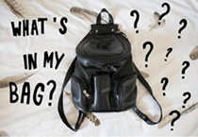
B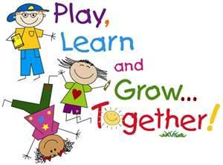
Authentic Outcome
Design and make re-usable cloth bags

Understanding The World
Past and Present

- Earth Day 22nd April ,Reuse, recycle bags. Reduce use of plastic bags.
- Use basic geographical vocab to refer to key physical & human features.
- Fieldwork trip to Goldsithney with an explorer’s bag to play I Spy
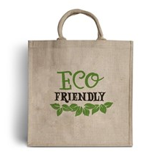
Expressive arts & design
- Weaving textiles/ sewing
- Look at design of various bags and materials used.
- Design & create cloth bags
- Joining skills, levers, woodwork.
- Study Kadinsky abstract artist, shape & colour
- Mixing colours, Primary & secondary colours
- Kapow Music
Literacy & Communication
Texts: The Huge Bag Of Worries. The Queen’s Handbag. The Jolly Postman. Jack & The Beanstalk. The Tiny Seed
- Role -Play: Post Office, letter/message writing.
- Persuasive letters/ Reduce plastic bags, use a bag for life!
- Level 4 Unlocking Letters & Sounds
- Dough disco/ handwriting & letter formation
- Story/poetry time, guided reading & Comprehension

Number, Numerical patterns

- Numbers up to 20 Counting & composition
- Adding/subtraction
- Doubling/sharing
- Odd/even
- Spatial reasoning, match, rotate, mapping
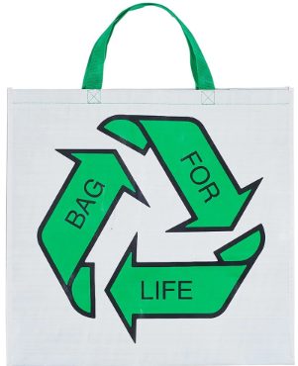
Understanding The World: Natural world.
- Growth, flowers, seeds, plants, trees.
- Grow own sunflowers, beans, and vegetables.
- Identifying trees and wildflowers in our locality.
- Scientific investigations, what makes a bag waterproof?
- Look at materials used to make bags

Physical Development
- Swimming
- Tennis
- Sports Day prep.
- Ball control skills.
- Fine/gross motor skills.
- Welly walks.

PSED
- JIGSAW Relationships, Changing me
- Earth Day
- Emergency Services, what’s in their bags?
- Transition to Year 1
- Social skills

Technology
- Internet Safety
- Beebots, programming, age appropriate apps
- Technology in our lives
Age approprie
RE/People & Communities
- Special places & special stories
- Local places of worship, Cornish churches.
- Open The Book assemblies
- The jobs people do in our community. Human geography

What you can do to support your child’s learning in this area:

- Visit the library to find topic books.
- Practise phonics & Common Exception words
- Share a book every day
- Practise counting & number bonds
- Talk about the environment. Recycle, reuse and reduce use of plastic, bags for life.
- Share hobbies, skills and interests

Useful links:
- www.teachyoumonstertoread.com/
- www.teachingyourchild.org.uk/
- www.bbc.co.uk/schools/scienceclips
- Apps for ipad, pirate phonics, maths bingo, beebots, writing wizard, One-minute maths
TRIPS/EXPERIENCES:
Welly walks
Visits from artists, doctor, police, fire brigade, bee keeper, people with hobbies/ talents in a bag.
Prussia Cove What’s In My Bag?
Entry Point: Fill a bag with special items that show who I am!

