
“Thrive has helped my son tremendously. It has given him more confidence and also it has helped him to calm down in difficult situations. I can see a huge difference in him. He looks forward to his Thrive time.”

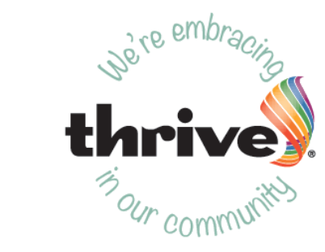

 St Hilary School
‘The best we can be’

Embracing Thrive: a parent’s guide

We want all the children in our community to flourish, so we have introduced The Thrive Approach in order to support their emotional and social development. Our aim is to help your children feel happy and secure, able to enjoy friendships, relate well to others and be ready and able to learn.
The Thrive Approach
Thrive is a specific way of working with all children that helps to develop their social and emotional well-being, enabling them to engage with life and learning. It supports them in becoming more self- assured, capable and adaptable. It can also address any troubled, or troubling, behaviours providing a firm foundation for academic attainment.

Positive relationships are at the heart of Thrive. We use these relationships, together with play and creative activities, to give children key experiences at each different stage of their development. Repetition of these activities supports their development, helping them to:

- feel good about themselves and know that they matter
- increase their sense of security and trust

- increase their emotional well-being

- improve their capacity to be creative and curious
- increase their self-esteem and confidence to learn
- learn to recognise and regulate their feelings
- learn to think before behaving in a certain way

- ...and much more.


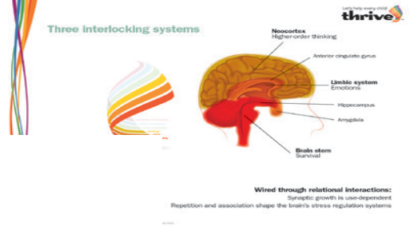








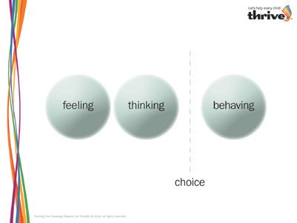
How does it work?

Appropriate for all children from birth to adulthood, The Thrive Approach draws on the latest research into brain science, child development theory and attachment theory. It helps us to understand how babies’ and children’s brains develop, and how parents, teachers and other professionals can best support this development by providing the best experiences for the children at each stage.

Thrive also helps us to better understand the children’s needs being signalled by their behaviour. Sometimes children may struggle as a result of temporary setbacks or other, longer term changes in their lives such as a separation, a bereavement, a family illness or accident, or even the arrival of a new baby. They may signal their distress by becoming more withdrawn, or distant, or perhaps more challenging or disruptive, or even by trying too hard to please. If this happens we use Thrive to look beyond the behaviour to give these children the support they need to get back on track. Sometimes they only need a little extra support in class and sometimes they may need additional one-to-one time to help them along.

How will my child be involved in Thrive?
We use a screening tool and activity planning resource called Thrive-Online. This allows us to check that children are working appropriately for their age and to support the whole group with activities that ensure that they are as emotionally and socially developed as they can be. Using Thrive-Online will also identify any children in need of extra help. If the screening process suggests that your child would benefit from additional one-to-one support, we will contact you and, with your consent and involvement, we will carry out a more detailed assessment to develop an action plan that gives us specific strategies and activities for supporting your child here. The plan will also suggest specific activities that you can do at home, so that together we can help them through any difficulties they are experiencing.
We understand that some circumstances may be sensitive and confidentiality will be paramount at all times when you are discussing your child’s needs with us.

How can I find out more?
Find out more about Thrive and how it can help change lives at www.thriveapproach.co.uk

“I thought I’d lost my boy. The Thrive staff gave him back to us!”
Your Thrive contact is:
Michelle Brant- SENCO
michellebrant@st-hilary.cornwall.sch.uk
The Thrive Practitioners are:
Miss Jodie Row
Mrs Sam Badcock

