**Class 4 – Gwithian**

Thinking about the past, the present and future- why is mining important to Cornwall?

**MATHEMATICS**

* Place Value (Tth,Th,H,T,U)
* Multiply and divide by 10, 100, 1000.
* Negative numbers in relation to temperature.
* Rounding numbers to the nearest 10,100, 1000.
* Standard methods for addition and subtraction.
* Develop multiplication and division knowledge and skills.
* Recognise and use factor pairs.
* Find the area of rectangles.
* Continue to practise times tables
* Solve number problems.

**ENGLISH**

* Stories based on imaginary characters – understanding structures of stories, developing knowledge and use of powerful vocabulary & comprehension of texts.
* Recounts linked to trip to Geevor
* Discussion texts – understanding purpose, layout, language and structure. Re-open Mines Vs Keep them closed.
* Performance poetry.
* Develop knowledge of spelling patterns and continue joined handwriting.

**TRIP - Geevor Mine**

**OUTCOME -** Come up with an inventive design to package traditional food, which would enable a person to dine in a mine. Enter the Dragons Den to showcase your product.

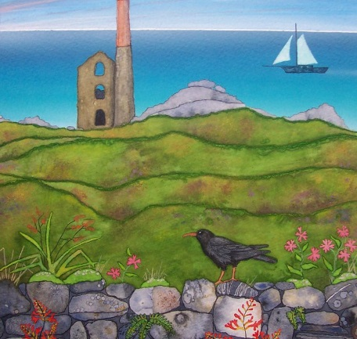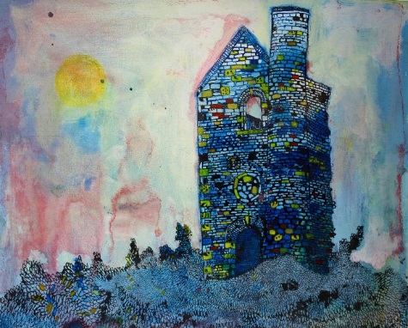

**SCIENCE**

Sound

* Understand how sound is made when objects vibrate.
* Investigate how sound travels through different materials including liquids.
* Investigate pitch & volume through making instruments.

Electricity

* Understand, draw and construct simple circuits.
* Identify, through investigation, the best conductors for electricity.
* Research & discuss scientist’s contribution to our understanding of electricity.

**ART/DESIGN/MUSIC**

Create a landscape in the style of a Cornish Artist. The children will learn about the different styles and techniques, developing their own skills by using a variety of different mediums.

Make traditional Cornish foods and display them in their own Cornish themed presentation box. (Croust bag or box)

Learn a Cornish hymn.

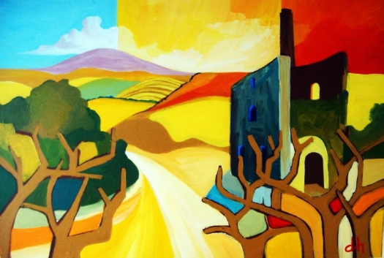

**COMPUTING** (ongoing skill development, plus ...)

Programming skills using Scratch and programming Lego to move.

**PSHE**

Being Me in My World: Understanding the rights, responsibilities and democracy in the school community.

Celebrating Difference:

Develop understanding of how others are different and how to celebrate this.

**PE**

* Invasion games (generic skills) including hockey, tag rugby & basketball.
* Circuit training – developing stamina & agility.

**RELIGIOUS EDUCATION**

Understand what Christians believe in and how this is reflected at Christmas.

Identify & Understand significant Jewish festivals.

**HISTORY/GEOGRAPHY**

Identify & understand Cornish History & Heritage including mining, smuggling, archaeology & landforms.

Recognise ways in which traditions and the Cornish way of life has changed over time.

Develop historical vocabulary.