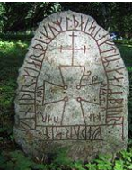

**ENGLISH**

* Persuasive Writing – Dragons for sale!
* Instructional Text – How to ______ . Children choose what area of Viking mythology they would like to instruct on.
* Fiction Writing – Write a myth inspired by Beowulf and Norse Mythology.

**HISTORY/GEOGRAPHY**

* Viking Runes, gods, culture and beliefs.
* Anglo-Saxon settlements, word derivations and trading routes.
* Battle
* Norse Mythology – Odin, Thor and Loki
* The dark ages – debate our essential question.

**MATHEMATICS**

* Identifying, rounding and comparing numbers up to a million.
* Explore negative numbers
* Add and subtract numbers with more than 4-digits.
* Explore the inverse operation.
* Complete multi-step word problems using addition and subtraction.
* Statistics
  + line graphs
  + Two way tables
  + Timetables

Class Reads

* How to Train Your Dragon (Cressida Cowell)
* Beowulf
* A Christmas Carol (Charles Dickens)

**PE**

* Netball
* Circuit Training
* Athletics

**GWENVER CLASS**

**ICT**

(Ongoing skill development, plus ...)

* I-movie ‘How to with ______’
* Conducting secondary research on historical events.
* Using technology safely, responsibly and respectfully.

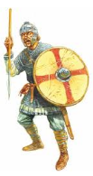

**THE DARK ARTS …**

**PSHE**

* Discussing both national and global affairs and their impact.
* Implementing e-safety strategies.
* Healthy Living using ‘JIGSAW’

**SCIENCE**

**Materials**

* Compare and group together materials based on their properties (this knowledge will be linked closely to our Design Technology project).
* Separating substances using our knowledge of solids, liquids and gases.
* Exploring reasons for particular use of everyday materials.
* Demonstrate that dissolving, mixing and changes of state are reversible changes.
* Explain that some changes result in the formation of new materials, and that this kind of change is not usually reversible, including changes associated with burning and the action of acid on bicarbonate of soda.

**Essential Question:**

**Were the dark ages truly dark?**

**REAL outcome:**

***Class 5 will host a ‘thing’ celebrating our new found knowledge of the Angles, Saxons, Vikings and the Dark Ages.***

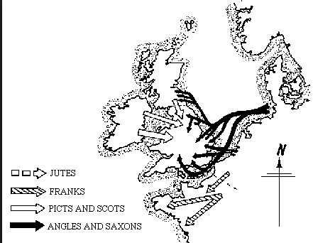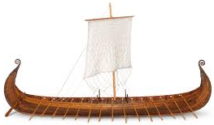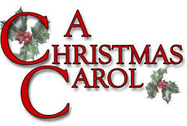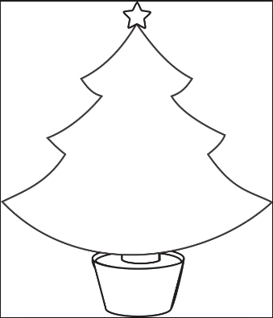

**ART/DESIGN/MUSIC**

* Design and make a 3D Saxon settlement.
* Sewing Viking badges
* Pencil line art using Viking ‘jelling’
* Rune stones
* Sketching a Viking long boat

**TRIPS/EXPERIENCES**

* **A Viking visits school**
* **Magic Show**
* **‘Thing’ celebration – role play**
* **I-movie ‘How to’ film.**
* Study of a Christmas Carol – C.S Lewis
* Marley’s chains – What are our chains?
* Sketch work inspired by P.J Lynch
* Scrooge – friend or foe? Debate
* Character comprehension and comparison.