[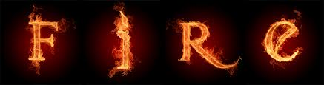](http://www.google.co.uk/url?sa=i&rct=j&q=&esrc=s&source=images&cd=&cad=rja&docid=8E_mvEKBg0DWMM&tbnid=GotY7-wyw5lszM:&ved=0CAUQjRw&url=http://www.magic-circle.co.za/fire-dancer-fire-poi-fire-entertainer-fire-eater-fire-thrower.html&ei=3Z69UqqQN8yb0wWK5YCADA&psig=AFQjCNE1HhRiqIsVZs_ahH5dMbNi1JnpTw&ust=1388244880291673)

**MATHEMATICS**

We will be recapping on concepts learned so far in Year 2 and building on their understanding and knowledge in the following areas.

* Reading and writing numbers to 100, comparing and ordering number and using ˂ and ˃ signs.
* Partitioning numbers into tens and units to make it easier for them to add them together. e.g 24+38 20 +30 then 4+ 8 then add together.
* Adding up to and beyond 100 using previous knowledge and known strategies as above to help them.
* Subtracting numbers up to 100, using a number line by counting back in multiples of tens and then taking away the units.
* Understanding that multiplication is repeated addition and to start learning the 2, 5 and 10 times tables.
* Introducing division as sharing and then linking it to multiplication facts.
* Using their knowledge of + - x and ÷ to solve real life problems.
* Reading bar charts and completing them using the data collected.
* Measuring using m, cm, g, kg, ml & l.

[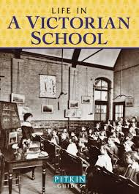](https://www.google.co.uk/url?sa=i&rct=j&q=&esrc=s&source=images&cd=&cad=rja&uact=8&ved=2ahUKEwi3zY_-tsXdAhUQYxoKHR6FBhwQjRx6BAgBEAU&url=https%3A%2F%2Fwww.pavilionbooks.com%2Fbook%2Flife-in-a-victorian-school%2F&psig=AOvVaw1Pb8-6r_Pl1zYcQUV0O6wU&ust=1537390142122471)

**SCIENCE**

We will be learning about materials.

How they are sustainable and make decisions on the most suitable materials to use.

Man-made and natural materials.

Classifying and identifying different materials.

A trip to visit Helston Museum to the Victorian Classroom.

**ENGLISH**

We will be :

* Reading daily and working on comprehension skills at the child’s level. This may be in a guided reading group or individually.
* Reading familiar stories and writing activities linked to these stories such as story endings, character descriptions, dairies and letters.
* Non-fiction writing about the Victorians.
* Persuasive writing about buying a toy.
* Writing simple descriptive poems.
* Using simple dictionaries and glossaries and making their own simple glossaries linked to their non-fiction writing.
* Continuing to join their writing and start to use known joins in their independent writing.
* Securing the use of sentences in their work.
* Starting to use commas to separate items in lists.
* Grammar and phonics recapping on sounds and focusing on suffixes and plurals.
* Learning to read/spell common exception words.

**PE**

Swimming – Penzance Leisure Centre

Hockey – generic team skills

**MUSIC**

Learning about long and short notes,

Singing and performing songs and writing scores.

**RE**

We will learn about:

The Hindu festival of Diwali. The creation story and Christmas

**HISTORY/GEOGRAPHY**

We will be learning about:

* Reading maps and recognising symbols.
* Making their own maps with a simple key of the school.
* Learn about Victorian schools and how we know about the past from different types of evidence.
* Learn how St Hilary has changed over the years by looking at old photographs and recognise changes in the building and clothes. Learn how the school daily routine, lessons have changed by listening to older members of the community.

**What you can do to support your child’s learning in this area:**

* Remember reading books every day and homework with handwriting for Wednesday.
* Read every day if possible and discuss the story or nonfiction text.
* Use Mathletics weekly aiming for 1000 points per week.
* Practise spellings for Friday
* Count up amounts of money and give change.
* Practise telling the time and how long journeys or television programs last.
* Learn the times tables
* Practise handwriting with a sharp pencil.
* Make sure they take care to present their homework well using a pencil.

**ART/DESIGN**

We will be:

Making Victorian toys such as windmill, hobby horses and peg dolls.

Making a photograph frame to display a photograph of themselves in Victorian clothes.

Activities linked with Christmas and Diwali such as cards and ceramic gifts.

Many opportunities to paint to link our English or topic work.

**Computing**

We will be:

Making and programming a Lego toy.

Using scratch to program a toy to move around the screen.

**PSHE**

We will be :

Setting ourselves challenges and learning how their behaviour affects others.

How manners, respect in schools today compares with the Victorian era.

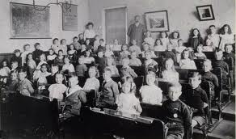

**Victorians**

**Porthcurno Class**

**Autumn Term 2018**