The Magic Box
by Gwithian Class 2017/18

I will put in the box
The sound of a snoring dragon,
The incredible shred of Eddie Van Halan’s Guitar solo,
The delicate sound of a snowflake.

I will put in the box
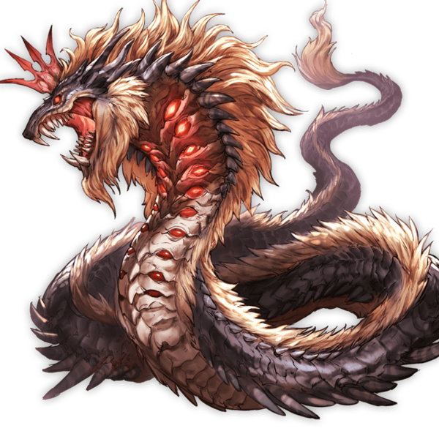
My teacher who teaches things that I never knew,
The menacing cry of a hideous, dreadful basilisk,
A violent volcano from a vicious mill,

The sound of rain on the top of a car,
The scream of a live hamburger sizzling on a stove,
The bright bloody lava from the biggest, deadliest, vicious volcano,

I will put in the box
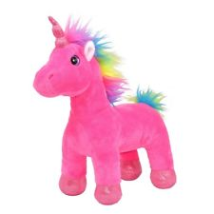
The crunch of a bourbon biscuit,
A tap of a pencil’s heart,
The pink horn of a young unicorn.

I will put in the box
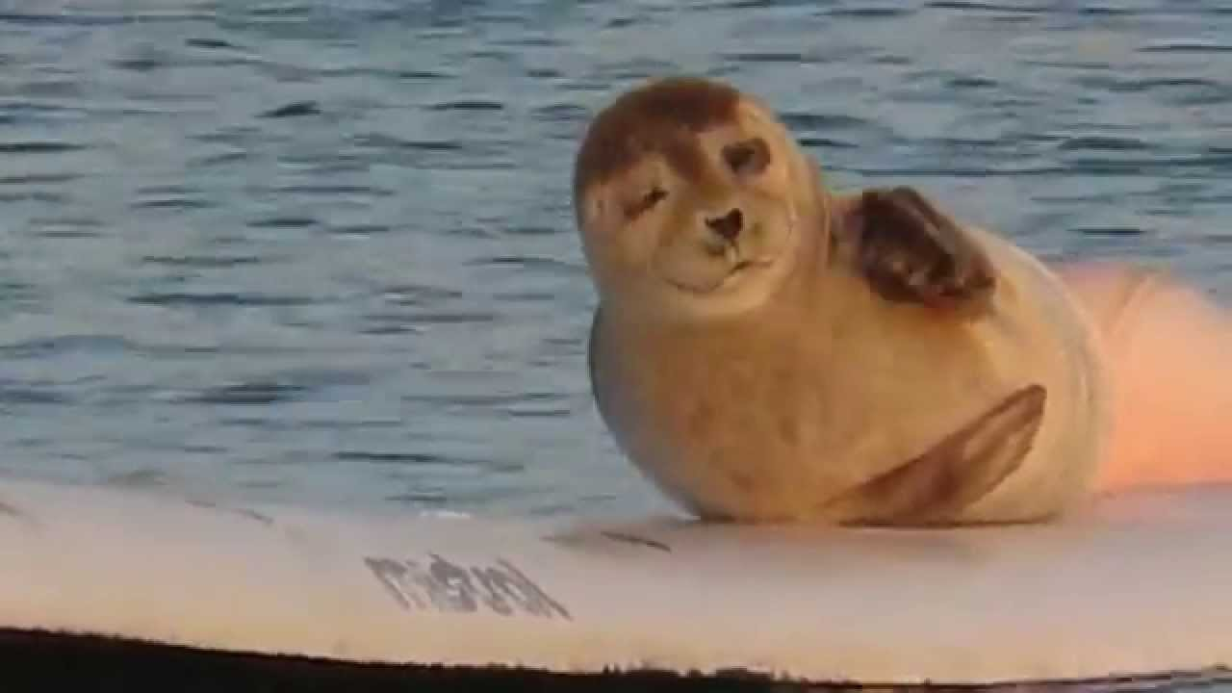
A lazy lady laughing like lollipops,
The penetratingly strong wind of a merciless snow-storm,
A seal from the sea surfing on a surfboard.

I will put in the box
The breeze of a snowstorm,
The swish of a green, ripped leaf on a winter’s day,
And a crumbling crystal knife.
I will put in the box
The tear of a whimpering wolf,
The cry of a snowman slowly melting,
A hairy handsome boy named Haiden

I will put in the box
A swish of a swirling fish,
The tear of a cramped crying cloud,
The first cry of a maricon kitten,

I will put in the box
Thunder from the thunderbird, flying high in the sky,
The last laugh of a lavender coloured fish,
The thump of a rhino’s charging foot.

I will put in the box
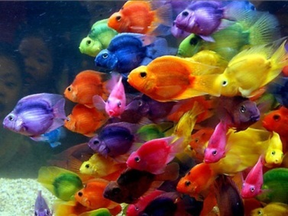
The thought of a thing from Mars,
A blood scented baby,
The loud blowing sound of leaves falling off trees in Autumn,

I will put in the box
A snort of a scornful boy,
Three talking stripy bees dancing in the rain,
An eruption of a volcano that roars up to the moon.

And watch out because I will also put in the box,
a demon hamster nibbling your fingers…ouch!

